Massage Client Intake Form
Personal Information

Name: Date:
Address:
City: State: Zip:
Phone: Email:
DOB: Age:
Sex: Occupation:
Emergency Contact: Phone:
History
How many days per week do you exercise? For how long:
Work Activity: ☐Sitting ☐Standing ☐Light Labor ☐Heavy Labor
Do you smoke? Have you ever smoked? How Often?
How much water do you drink per day?
How many caffeinated or alcoholic beverages do you have per day?
What Medications are you currently taking?
Previous complaints/surgeries/medications?
What is your Major Complaint?
Have you seen a massage therapist before?
Goals for massage today? ☐Relaxation ☐Rehabilitation ☐Maintenance
What kind of pressure do you prefer? ☐Light/Meditative ☐Moderate/Medium ☐Deep

☐ Aids/HIV ☐Depression ☐Hernia ☐Pins/Pacemaker
Have you Had any of the Following? (Check all that Apply)

☐Arthritis ☐Diabetes ☐Herniated Disk ☐Poison Ivy
☐Asthma ☐Dizziness ☐High Blood Pressure ☐Pregnancy
☐Bleeding Disorders ☐Epilepsy ☐Fibromyalgia ☐Scoliosis
☐Cancer ☐Headache/Migraine ☐Irritated Skin Rash ☐Severe Pain
☐Current Cold or Flu ☐Heart Disease ☐Low Blood Pressure ☐TMJ/ Jaw Pain
☐Cuts, Burns, Bruises ☐Hepatitis ☐Osteoporosis ☐Varicose Veins
☐Other_____________________

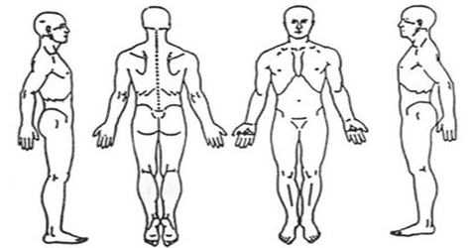
Mark Areas of Discomfort

Consent for Treatment
If I experience any pain or discomfort during this session, I will immediately inform the practitioner so that the pressure and/or strokes may be adjusted to my level of comfort. I further understand that massage/bodywork should not be construed as a substitute for medical examination, diagnosis, or treatment and that I should see a physician, chiropractor, or other qualified medical specialist for any mental or physical ailment of which I am aware. I understand that massage/bodywork practitioners are not qualified to perform spinal or skeletal adjustments, diagnose, prescribe, or treat any physical or mental illness, and that nothing said in the course of the session given should be construed as such. Because massage/bodywork should not be performed under certain medical conditions, I affirm that I have stated all my known medical conditions and answered all questions honestly. I agree to keep the practitioner updated as to any changes in my medical profile and understand that there shall be no liability on the practitioner’s part should I fail to do so. I also understand that any illicit or sexually suggestive remarks or advances made by me will result in immediate termination of the session, and I will be liable for payment of the scheduled appointment. Understanding all of this, I give my consent to receive care.
Client Signature: _____________________________________________________________ Date: ____________
Parent or Guardian Signature (in case of a minor): ___________________________________ Date: ____________
Office polices
Please be advised of the policies for this office. Your signature below signifies acceptance of these policies.
Cancellation: A 24-hour notice is required for cancellation of an appointment, or you will be charged in full for the appointment. Payment is due before your next appointment.
Tardiness: Appointment times are as scheduled and cannot extend beyond the stated time to accommodate late arrivals. Please be on time to your appointment.
Sickness: Massage/bodywork is not appropriate care for infectious or contagious illness. Please cancel your appointment as soon as you are aware of an infectious or contagious condition. If it is within the 24-hour notice period, the cancellation fee may be waived.
Client Signature: _____________________________________________________________ Date: ____________

